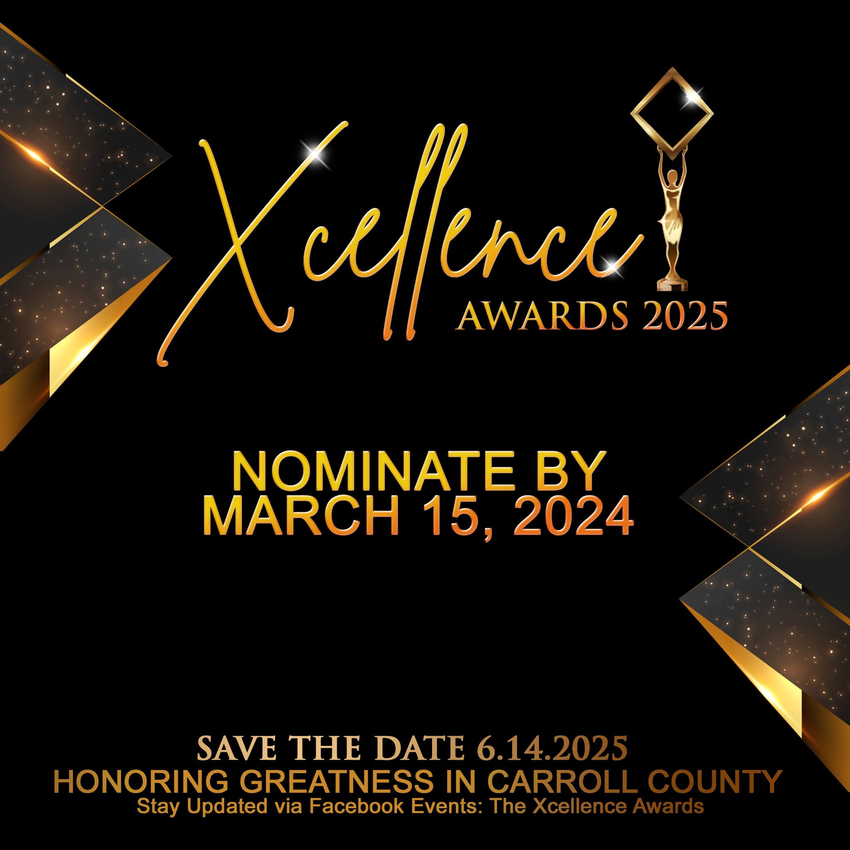
SPONSORSHIP PROPOSAL
Executive Summary
The Xcellence Awards is an esteemed event dedicated to recognizing and celebrating minorities/minority-owned businesses and organizations in Carroll County that have made a substantial positive impact on the community. Scheduled for Saturday, June 14, 2025, from 2pm to 7pm at True Life Church 78 Blackstock Rd Villa Rica GA. The Xcellence Awards aims to spotlight positive contributions and empower the ongoing greatness within minority communities. This is a Carroll County wide event.
Mission Statement
Our mission is to host an impactful event that celebrates and honors minorities for their outstanding positive contributions to our community. Through recognition and appreciation, we strive to empower and inspire continued greatness within minority communities. This event serves as a beacon of acknowledgment, fostering unity and amplifying the diverse voices that shape a more vibrant and inclusive society.
Event Details
We will honor 20 amazing individuals or companies/organizations that serve in Carroll County, GA. We are recognizing educators, artists, leaders, professionals, community workers, trailblazers, and many more! The community is allowed to nominate individuals by the criteria listed below. Nominations took place online from January 15, 2024, 12am - March 15, 2024, 11:59pm. Chosen nominees have been listed and shared with the community on our Facebook page at www.Facebook.com/CCXcellence . The top 3 will be named at The Xcellence Awards. However, only the one will be honored at the event with an award. Voting on the top 5 nominees is taking place since March 16, 2024 12:00 am- June 15, 2024 11:59pm. Nominees are still listed online at: https://s.surveyplanet.com/0xschg9i (Voting is now closed)

Awards & Criteria for nominations:
- Leading Boldly Politician Award - The person you nominate needs to be a minority who has served as a politician of Carroll County and made a significant impact as a politician in the community of Carroll County. This person must have served within the last five years.
- Most Valuable Coach Award - The person you nominate needs to be a minority who has made a significant impact as a coach in the community of Carroll County. This person must have served as a coach within the last 3 years in Carroll County.
- Xceptional Nonprofit Award - The person/agency you nominate needs to be a minority who has made a significant impact with as a Nonprofit in the community of Carroll County. This person/agency must be an active nonprofit serving for at least 3 years.
- Youth Impact Award - The person/agency you nominate needs to be a minority who has made a significant impact with the youth in the community of Carroll County. This person must have worked with the youth directly for at least 3 years within the last 3 years. This person must be a positive role model for the youth.
- Greatness in Education Award - The person/agency you nominate needs to be a minority who has made a significant impact within the Education System in Carroll County. You must work/have worked in the education system within Carroll County School systems. Must have served within the last 3 years.
- Business Owner of the Year - The person/agency you nominate needs to be a minority who has made a significant impact within the Education System in Carroll County. You must work/have worked in the education system within Carroll County School systems. Must have served within the last 3 years.
- Event of the Year - The person/agency you nominate needs to be a minority who led/held an event within the last 3 years that made a significant impact in Carroll County.
- Youngest in Power Award - The person/agency you nominate needs to be a minority who is under the age of 18 that made a significant impact in Carroll County. Significant impact can include excelling academically, athletically, as business owner, or artistically.
- Ministry Making an Impact Award - The person/church you nominate needs to be a minority who leads a ministry in Carroll County that made a significant impact several times within the last 3 years.
- Creative Work Award - The person/company you nominate needs to be a minority who has creative works of art in Carroll County; can include but not limited; author, painter, photography, graphics, musically, dancing, and videography. Must have provided arts within the last 3 years.
- Xcellence in Beauty Award - The person/company you nominate needs to be a minority who provides beauty services in Carroll County. This person should consistently show integrity, superior service & skill. Must reside in Carroll County & provide services to Carroll County residents currently and at least the last 3 years.
- Xcellence in Barbering Award - This person should consistently show integrity, superior service & skill. Must reside in Carroll County & provide services to Carroll County residents currently and at least the last 3 years.
- Greatness in Health Award - The person/company you nominate needs to be a minority who is a licensed doctor and has made a significant impact in Carroll County. Must reside in Carroll County.
- Healing Mental Health Award - The person/company you nominate needs to be a minority who is a licensed therapist and has made an impact in Carroll County as a licensed therapist, counselor, or social worker. Must reside in Carroll County.
- Lifetime Exemplary Leadership Award - The person you nominate needs to be a minority who is an exemplary leader and efforts have made an impact in Carroll County several times in several ways over the last 10 years. Must have maintained exemplary behavior over 10 years. Must have served in a leadership capacity in Carroll County. Must have made a significant change within the community of Carroll County. *The top 3 nominees will be interviewed in person via video by Xcellence Commitee about work completed and significant impact made over the last 10 years, and any upcoming projects. The winner chosen interview will be shown at the event.
- Outstanding Community Service Award - The person you nominate needs to be a minority who has made a significant impact in the community of Carroll County. Must have served in a nonprofit organization, or gave back to the community significantly; educationally, financially, resourcefully, economically, etc., or led an event that gave back to the community significantly or led a positive grassroots movement and made significant impact within the last 3 years. The top 3 nominees will be interviewed in person via video by The Xcellence Awards Committee about work completed and significant impact made over the last 10 years, and any upcoming projects. The winner chosen interview will be shown at the event.
- Legacy Cycle Breaker Award - The person you nominate needs to be a minority who is/has changing multi-generational family patterns within their family in Carroll County. The top 3 nominees will be interviewed in person via video by the Xcellence Awards Commitee about work completed and significant impact made over the last 10 years, and any upcoming projects. The winner chosen interview will be shown at the event.
- Crown Her Women Empowerment Award - The person you nominate needs to be a minority who has empowered women and serving for the last 3 years within Carroll County.
- King in Him Men’s Empowerment Award - The person you nominate needs to be a minority who has empowered men within Carroll County and serving for the last 3 years.
- Game Changer Judicial Award - The person you nominate needs to be a minority who has made an impact within the judicial system in Carroll County. This person must serve currently and have worked within the judicial system for at least a year, within the justice system in Carroll County.

This is a red-carpet event with a dress code of black formal attire; no jeans, T-shirts, or caps will be allowed. We will have two photo op options, Step & Repeat Backdrop of Gold & Diamond Level sponsors’ logos, with red carpet & a magazine box. This event will also be elegantly decorated.

Marketing
The Xcellence Awards will utilize the following ways to market the event:
Press Release: Send out a detailed Press Release to local magazines, local news stations, local community leaders, local business owners, and local organizations.

- Social Media Blitz 650k Followers total between the organizers’ social media pages & website): Leverage the extensive reach of the organizers' social media handles and website, utilizing their 30% engagements through regular posts, stories, and updates. Create visually appealing content, share nominee highlights, and showcase the significance of The Xcellence Awards, building anticipation leading up to the event. Ongoing and increasing as event gets closer.
- Local Magazine Advertisement: Secure an advertisement slot in a prominent local magazine, reaching a broader audience beyond the digital space. Craft a compelling ad that highlights the event's uniqueness, key sponsors, and the impactful contributions of minorities in the community. A month before the event.

- Direct Mail Campaign to Local Minority Businesses and Organizations: Implement a targeted direct mail campaign to reach local minority businesses and organizations. Design and send out visually appealing mailers that provide essential details about The Xcellence Awards, emphasizing the opportunity for recognition and celebration. Include information on sponsorship packages and event highlights to encourage participation. A month before the event.

These multifaceted marketing strategies aim to maximize visibility, engage diverse audiences, and generate excitement and interest in The Xcellence Awards.

Bronze Package $800
Join us in celebrating excellence while maximizing your brand exposure and community engagement. The Bronze Sponsorship Package includes:

Social Media Exposure: Prominent monthly promotion for any business/organization of your choosing leading up to the event on social media with a combined reach 650k Accounts & 30% Engagements across organizers' social media platforms and website. Promotions are 3 months.

Tax Deductible Letter: Given that Starr Resources is an established Nonprofit 501c3, and Xcellence Awards is a fundraiser for Starr Resources, your donation will be recognized as a donation and is tax deductible.

Event Access: Premium Seating, Two event tickets, 2 Xcellence T-shirts, and 2 Xcellence Programs.

Sponsorship Packages can be purchased until May 15, 2025. However, with late purchase you will not be able to take full advantage of incentives. There is unlimited amount of Bronze Sponsorship Packages available. However only 20 total Gold & Diamond Level Sponsorship packages are available and are first come first served.

If you would like to donate monetary or services, outside of the sponsorship packages, please email CarrollCountyXcellenceAwards@gmail.com to learn about what single donator are provided. *It’s dependent on details of what’s donated.

Gold Package $1,500
Join us in celebrating excellence while maximizing your brand exposure and community engagement. The Gold Sponsorship Package includes:

Social Media Exposure: Prominent monthly promotion for any business or organization leading up to the event on social media with a combined reach of 650k Accounts & 30% Engagements across organizers' social media platforms and website. Promotions are 3 months.

Award Association: Company name attached to a specific award, thoughtfully chosen by the Xcellence Award Committee to align with your business. Ensuring relevance among fellow sponsors and selecting the best fit for the award. Your chosen sponsorship award will be announced “Company presents Specific Award.”

On-Screen Recognition: Your company name presents the award, with the logo showcased on the screen during the presentation of that specific award.

Print Presence: Half-page advertisement in the Xcellence Magazine, featuring detailed company information or one striking flyer. The magazine will be distributed to 140 attendees at the event.

Tax Deductible Letter: Given that Starr Resources is an established Nonprofit 501c3, and Xcellence Awards is a fundraiser for Starr Resources, your donation will be recognized as a donation and is tax deductible.

Event Access: Premium Seating, 4 event tickets, 4 Xcellence T-shirt, and 4 Xcellence Programs.

Sponsorship Packages can be purchased until May 15, 2025. However, with late purchase you will not be able to take full advantage of incentives. There is unlimited amount of Bronze Sponsorship Packages available. However only 20 total Gold & Diamond Level Sponsorship packages are available and are first come first served.

If you would like to donate monetary or services, outside of the sponsorship packages, please email CarrollCountyXcellenceAwards@gmail.com to learn about what single donator are provided. *It’s dependent on details of what’s donated.

Diamond Packages $2,500
Join us in celebrating excellence while maximizing your brand exposure and community engagement. We are only accepting 1 Gold sponsor per award given (20). The Diamond Sponsorship Package includes:

Social Media Exposure: Prominent monthly promotion of any business or organization leading up to the event on social media with a combined reach of 650k Accounts & 30% Engagements across organizers' social media platforms and website. Promotions are 3 months.

Logo Visibility: Company logo prominently displayed on the step and repeat backdrop that will be utilized for photo ops at the event.

Award Association: Company name attached to a specific award, thoughtfully chosen by the Xcellence Award Committee to align with your business. Ensuring relevance among fellow sponsors and selecting the best fit for the award. Your chosen sponsorship award will be announced “Company presents Specific Award.”

On-Screen Recognition at The Xcellence Awards: Your company name presents the award, with the logo showcased on the screen during the presentation of that specific award.

On-Screen Recognition on Commercials used on Social Media & Website: Your company name, with the logo showcased, and your contact information and/or website shown in sponsor credits.

Print Presence: Full page advertisement in the Xcellence Magazine, featuring detailed company information or one striking flyer. The magazine will be distributed to 140 attendees at the event.

Xcellence Gift Package: 2 Xcellence Gift Packages with products from local Carroll County business owners.

Tax Deductible Letter: Given that Starr Resources is an established Nonprofit 501c3, and Xcellence Awards is a fundraiser for Starr Resources, your donation will be recognized as a donation and is tax deductible.

Event Access: Premium Seating at the event, 6 event tickets, 6 Xcellence T-shirts, and 6 Xcellence Programs.

Sponsorship Packages can be purchased until May 15, 2025. However, with late purchase you will not be able to take full advantage of incentives. There is unlimited amount of Bronze Sponsorship Packages available. However only 20 total Gold & Diamond Level Sponsorship packages are available and are first come first served.

If you would like to donate monetary or services, outside of the sponsorship packages, please email CarrollCountyXcellenceAwards@gmail.com to learn about what single donator are provided. *It’s dependent on details of what’s donated.

Xcellence Program Advertisements

Half-Page Ad $75: Half-page advertisement in the Xcellence Program, featuring detailed company information or one striking flyer. The magazine will be distributed to 140 attendees at the event.

Tax Deductible Letter: Given that Starr Resources is an established Nonprofit 501c3, and Xcellence Awards is a fundraiser for Starr Resources, your donation will be recognized as a donation and is tax deductible.

Full-Page Ad $115: Full-page advertisement in the Xcellence Program, featuring detailed company information or one striking flyer. The magazine will be distributed to 140 attendees at the event.

Tax Deductible Letter: Given that Starr Resources is an established Nonprofit 501c3, and Xcellence Awards is a fundraiser for Starr Resources, your donation will be recognized as a donation and is tax deductible.

If you would like to donate monetary or services, outside of the sponsorship packages, please email CarrollCountyXcellenceAwards@gmail.com to learn about what single donator are provided. *It’s dependent on details of what’s donated.

Budget
 | Expenses |  | Received Donations |  | Balance Needed
1. | Venue  True Life Church | $300 | Confirmed Sponsor England Graphix | -$300
2. | Event Décor  Majestically Fabulous Events | $2,500 |  |  | $2500
3. | Xcellence Program Printed  Acra Printing | $1,500 |  |  | $1500
4. | Photographer | $1,000 |  |  | $1000
5. | Videographers  Mindset Media | $600 | Confirmed Sponsor England Graphix | -$600
6. | Photo Ops  (Step & Repeat/ Photo Box) | $2,000 | Confirmed Sponsor Anything You Want LLC & England Graphix | -$2000
7. | Xcellence T-Shirts  Zyon Mullins | $1,200 |  |  | $1200
8. | Awards  McEver Awards | $1,500 |  |  | $1500
 | Total | $10,600 | Total | -$2,900 | $7,700

Event Organizers’ Profiles
Porsha Starr, a dedicated community leader, channels her passion into making a positive impact. By day, she serves as a compassionate social worker, bringing her expertise to uplift and support individuals. In addition to her professional role, Porsha holds the position of Chair at Women In NAACP, contributing to the advancement of women's causes.

Porsha is also a long-term business owner of England Graphix; a marketing & graphics firm. She has provided artistic work and marketing consultation that has grown businesses in 21 states in the U.S.

Furthermore, Porsha is the Director of Starr Resources, a 501c3 organization committed to empowering, supporting, and educating parents in Carroll County. Through her multifaceted roles, Porsha exemplifies a steadfast commitment to the Carroll County community well-being and the promotion of positive change.

Quan Smith is a Licensed Professional Counselor by day with a passion for assisting minorities in healing. Quan also serves as the Co-Chair on Women In NAACP Women’s Program. Finally Quan hosts events. And has made many impactful contributions to her community.

Emmanuel Mincey is a seasoned professional with 8 years of experience in the digital marketing arena. Specializing in maximizing the monetization of products and communities through digital ads, Emmanuel has made significant contributions to a diverse range of clients and organizations.

His expertise has been instrumental in assisting renowned figures such as Stephen A. Smith, the Thurgood Marshall College Fund, Warner Music, several Historically Black Colleges and Universities (HBCUs), Cinnabon, Nothing Bundt Cakes, and many others.
Emmanuel's consulting prowess extends to cultivating the followings of entertainers and educators nationwide, including notable personalities such as 19 Keys, Ray Daniels, and Blue and Red Pill.

Currently serving as the Director of Community Engagement and Monetization at Winsflow Digital, Emmanuel plays a pivotal role in shaping the company's strategies. Additionally, he holds a key position with the It's Your Time Conference, founded by entertainment legend Benny Pough, where he continues to make impactful contributions to the industry.

Marcus Dunson

Contact
Stay Updated on The Xcellence Awards via our Facebook Page www.Facebook.com/CCXcellenceAwards
Contact for more information: CarrollCountyXcellenceAwards@gmail.com
Sponsorship Registration
To become a Sponsor please send the following information to CarrollCountyXcellenceAwards@gmail.com:

Name:
Phone Number:
Email Address:
Company/Organization:
Package Choice:

Bronze $800
Gold $1,500
Diamond$2,500
Names of Attendees that will accompany you:

Bronze 1 additional attendee
Gold 3 additional attendees
Diamond 5 additional attendees
T-shirt Sizes:
Bronze 2 sizes Needed
Gold 4 sizes
Diamond 6 sizes
Please be sure to attach logo via email
Website/Social Media Link
Payment Choice:
Receive Invoice via Email
Cashapp: Cashapp $StarrResources
Check: Make check out to Starr Resources
Mail: P.O. Box 16 Winston GA 30187

