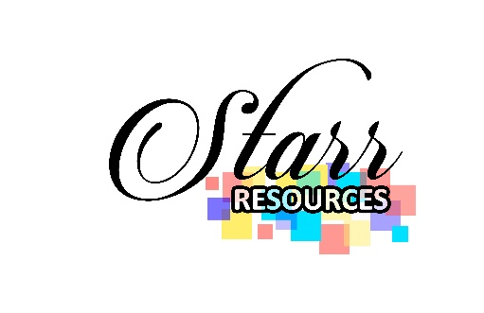

FINANCIAL ASSISTANCE APPLICATION
Financial Assistance can be used for rent, mortgage, lights, and or water bill. Must have employment or recently lost employment through no fault of your own. Amount given is dependent on availability of funds. First come first served. Can only receive funds once every 6 months. Must be a parent. Must take a set of parenting classes or a life skills class free of charge to qualify for financial assistance. Class types depends on situation, must be relevant to your specific situation. Must reside in serving County.

Contact Information
Full Name: |  |  |  | Date:
 | Last | First | M.I.

Address:
 | Street Address | Apartment/Unit #

 | City | State | ZIP Code

Phone: |  | Email

_____________________________________________________________________

Employed: Yes or No
Employer: ______________________________________________________________________
What do you plan to do with the financial assistance?

Please attach:
- Bill or corresponding document
- Class completion certificate

Consents
Please initial where you consent.
Please initial beside each term listed to acknowledge that you understand the term listed and any noncompliance could result in dismissal from the W.I.N. Mentorship Program
- I participated in one set of Parenting Education Classes or Life Skill Classes provided by Starr Resources.
- I will use the requested funds only what I put in this application.
- I understand that I cannot apply for funds again for another 6 months.

I certify that the information that I have provided on this application are true and complete to the best of my knowledge. I understand that false or misleading information in my application may result in denial of financial assistance.

Signature: |  | Date:

